Ministry of Higher Education and Scientific Research

Université de Carthage

Higher Institute of Information and Communication Technologies



**Requirements Specification Report**

# aplication web name: “**my Club life”**

### Introduction

Starting university can be a daunting experience for new students, with so much to learn and discover in a new environment. University clubs can provide a valuable source of community, social engagement, and personal development for students. However, with so many clubs to choose from, it can be difficult for new students to know where to start.

"My Club Life" (MCL) is a web application that serves in the social domain by providing a platform for students, specifically the new ones to explore clubs in their university and help them decide their future club life. The web app allows students to search for and discover clubs in their university based on their interests, skills, and goals. It uses a system that evaluates clubs based on various criteria such as club size, activities and events. The system also recommends clubs to students, as well as making it possible for them to rate and review a club based on the experience they had after they joined.

The app also provides a space where clubs can compete through an annual event for a more important grade in the website.

### List of Actors + Functional Needs

Actors:

Student - Users who are either new to the university or already members of a club.

Club Member - Users who can rate and leave a review about their club.

Club Manager - Users who manage and lead a specific university club.

Admin - Users who have full control over the web app including it's database and source code.

Functional Needs:

Student:

. As a student, I can read about clubs in my university.

. As a student, I can apply for clubs.

Club Member:

. As a club member, I can rate clubs and leave reviews to help other students make informed decisions.

. As a member, I can read about clubs in my university.

. As a member, I can rate clubs and leave reviews to help other students make informed decisions.

Club Manager:

. As a club manager, I can read about clubs in my university.

. As a club manager, I can manage my club and its members.

. As a club manager, I can promote club activities and events to members and potential members.

. As a club manager, I can receive notifications for new member requests and respond accordingly.

. As a club manager, I can access member information and update club information as necessary.

Admin:

. As an admin, I can manage clubs registered in the web app.

. As an admin, I can manage user accounts.

. As an admin, I can create and manage competitions that clubs can participate in.

. As an admin, I can access website analytics and generate reports on club activity and engagement.

### Non-Functional Needs

Performance: The system should respond to user requests within a certain timeframe and be able to handle a certain number of requests simultaneously.

Scalability: The system should be able to handle increased loads as user traffic grows without degrading performance.

Security: The system should protect sensitive information from unauthorized access or hacking attempts.

Reliability: The system should be available and functioning correctly at all times, with minimal downtime or errors.

Maintainability: The system should be easy to modify and update as requirements change or new features are added.

### COception UML

## • Use case diagrams:

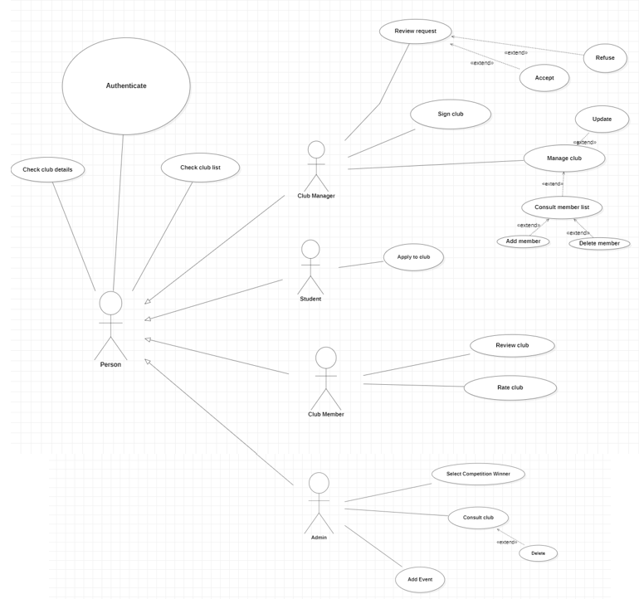

## • Sequence diagrams:

#### Admin:

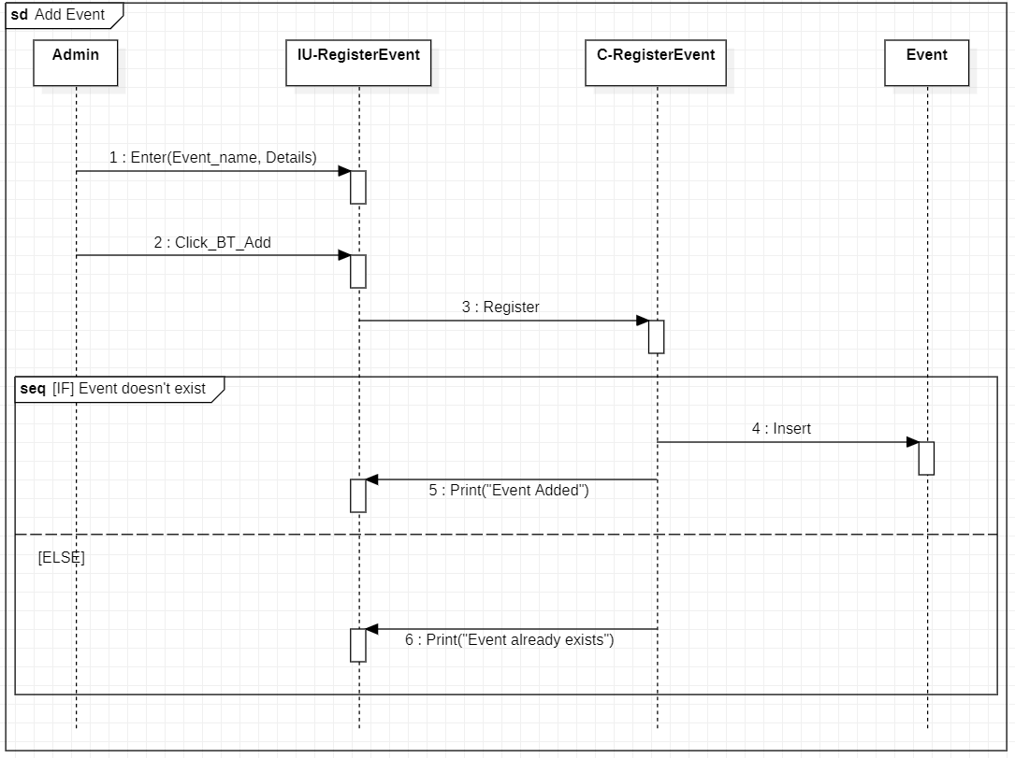

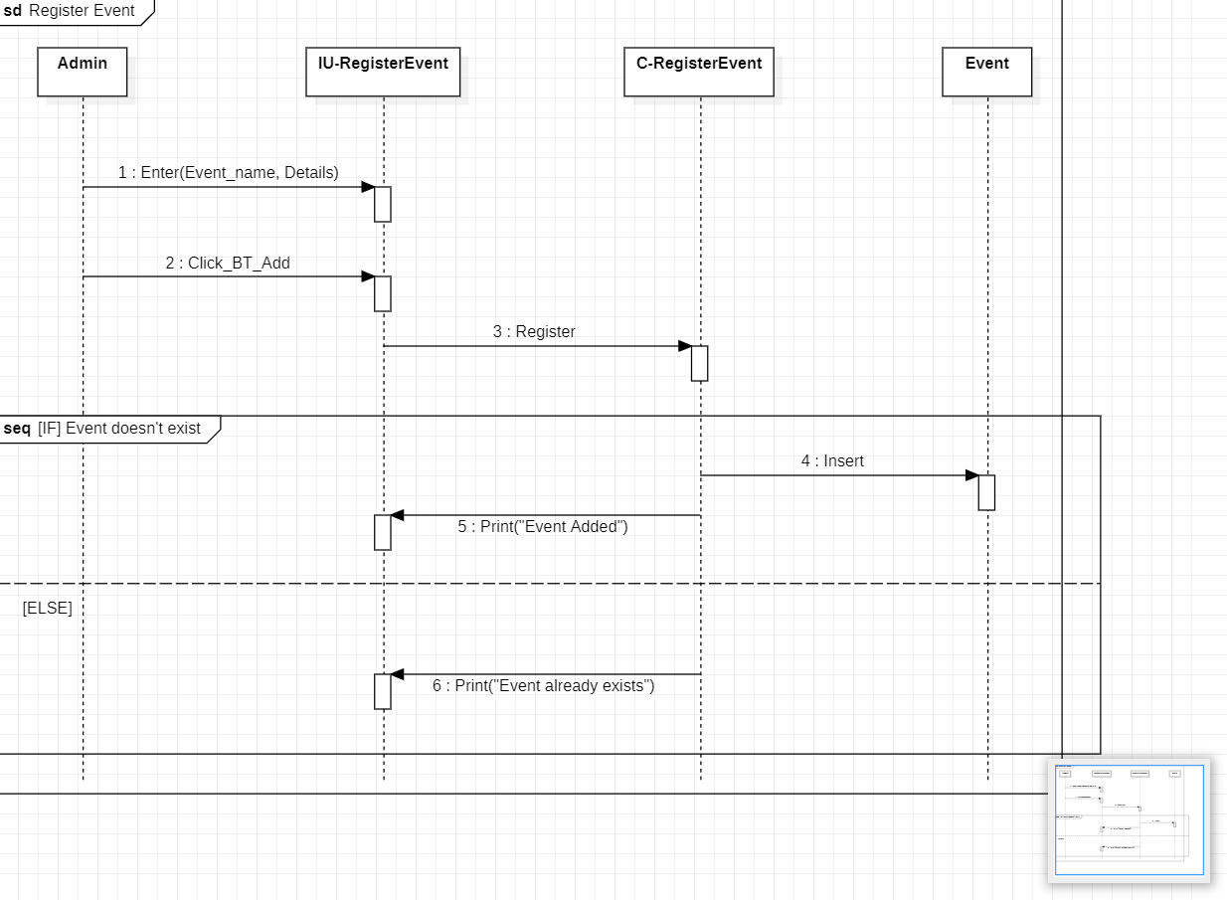

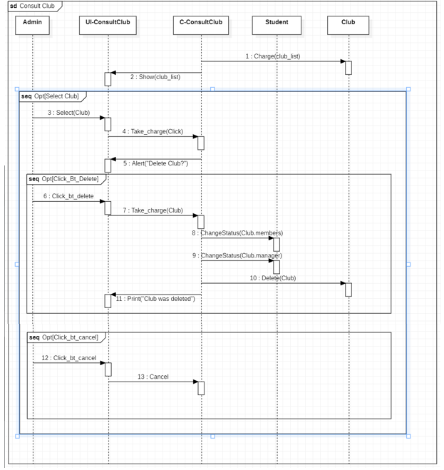

#### Club manager:

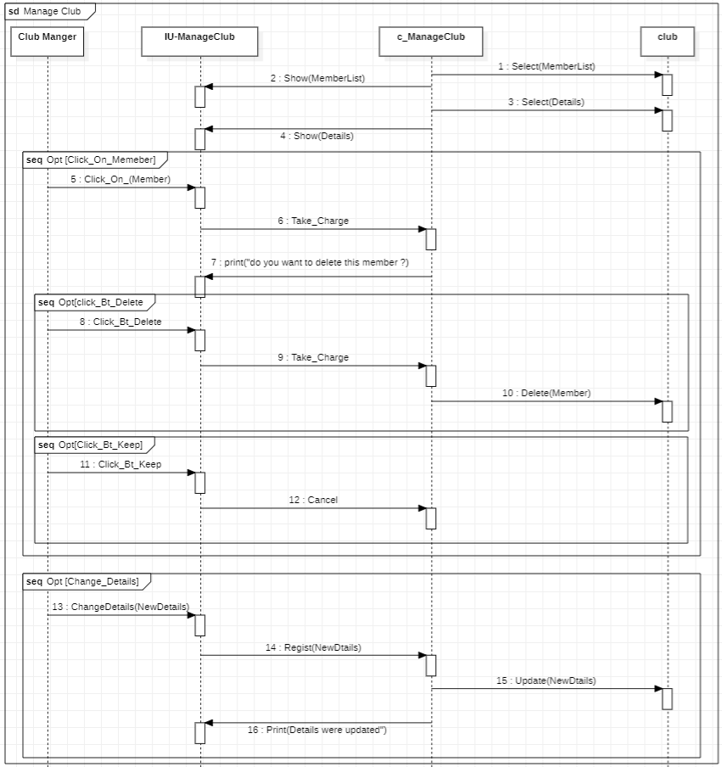

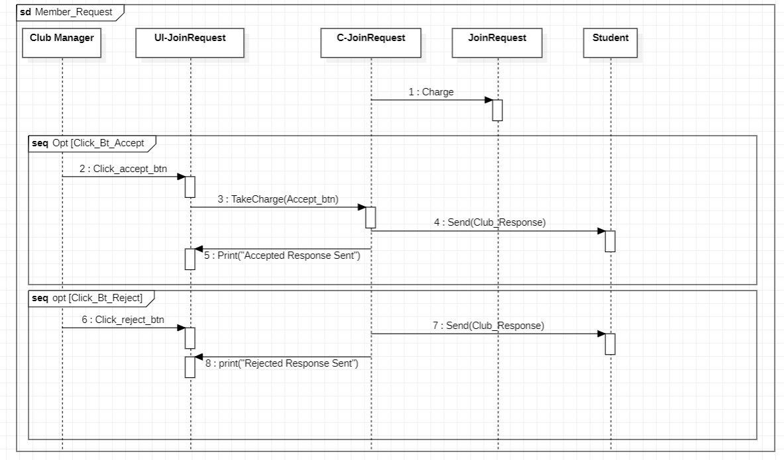

#### Person:

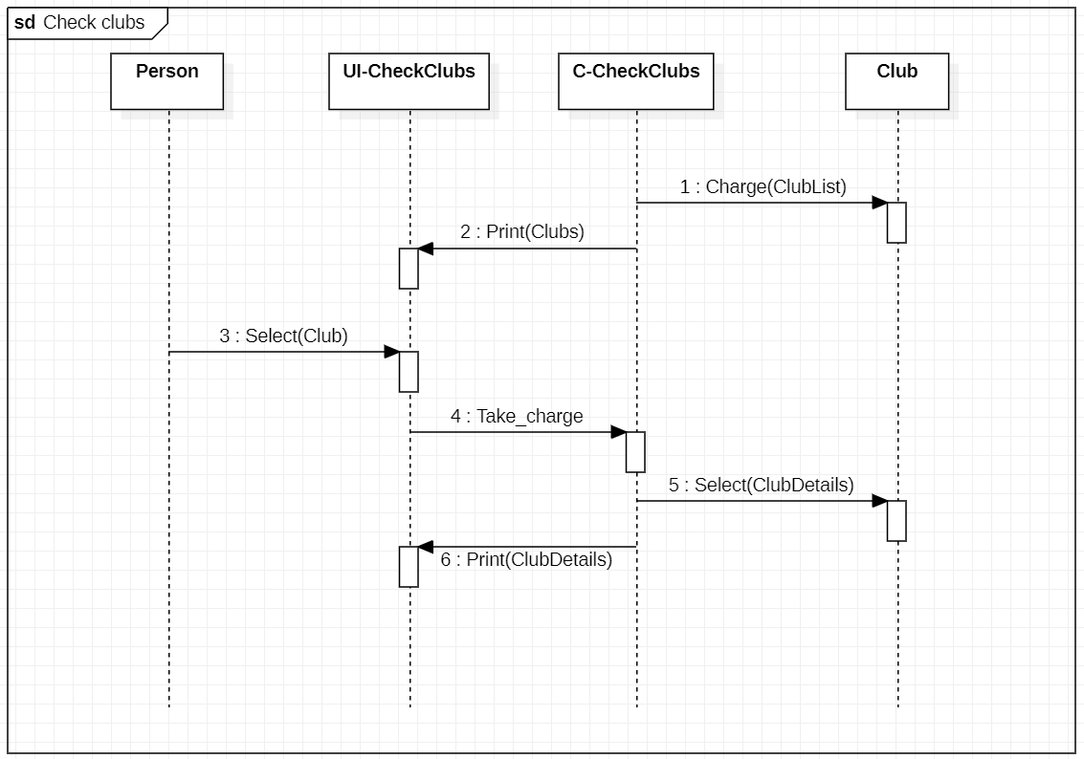

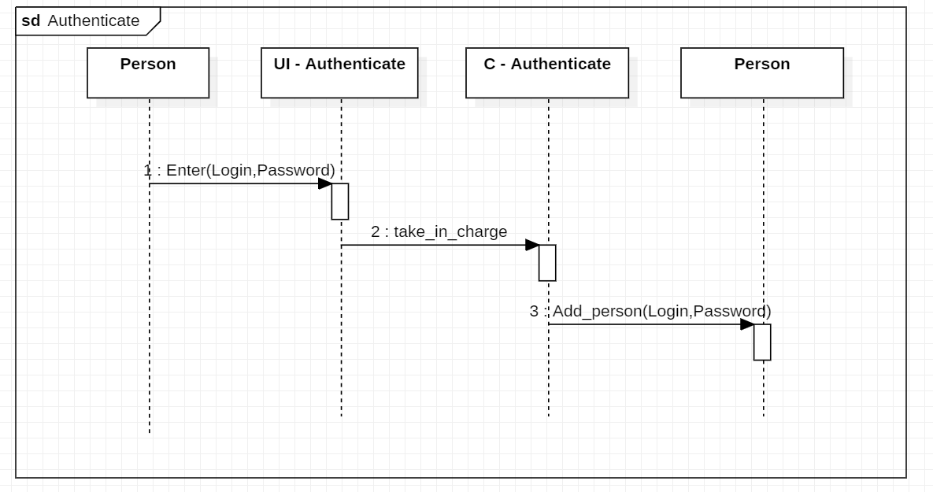

#### Club member:

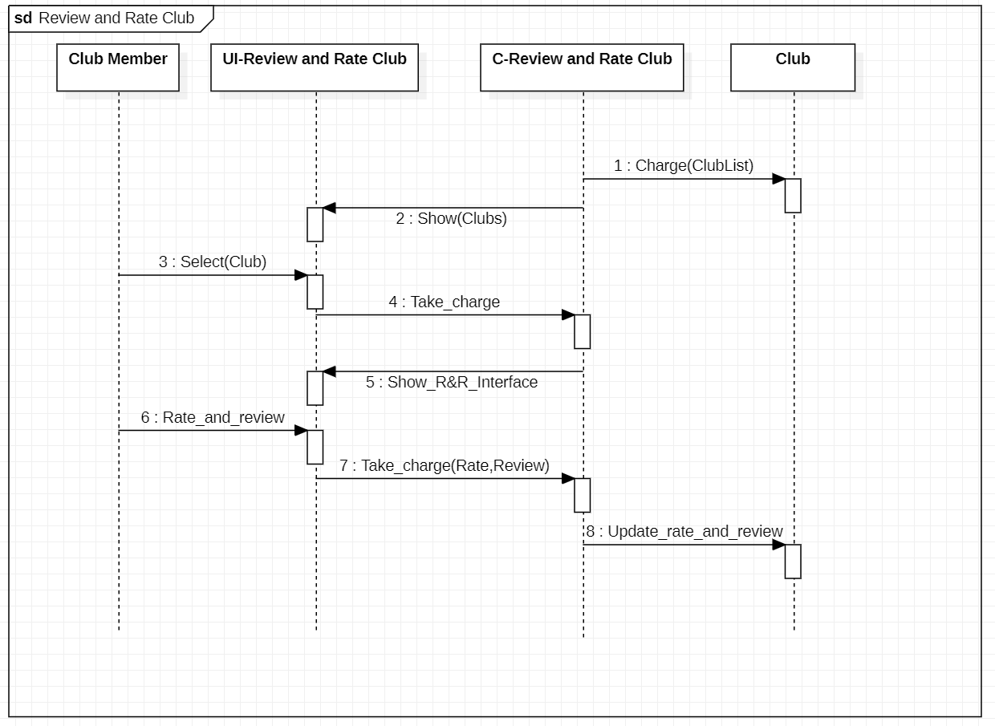

#### ***Student***:

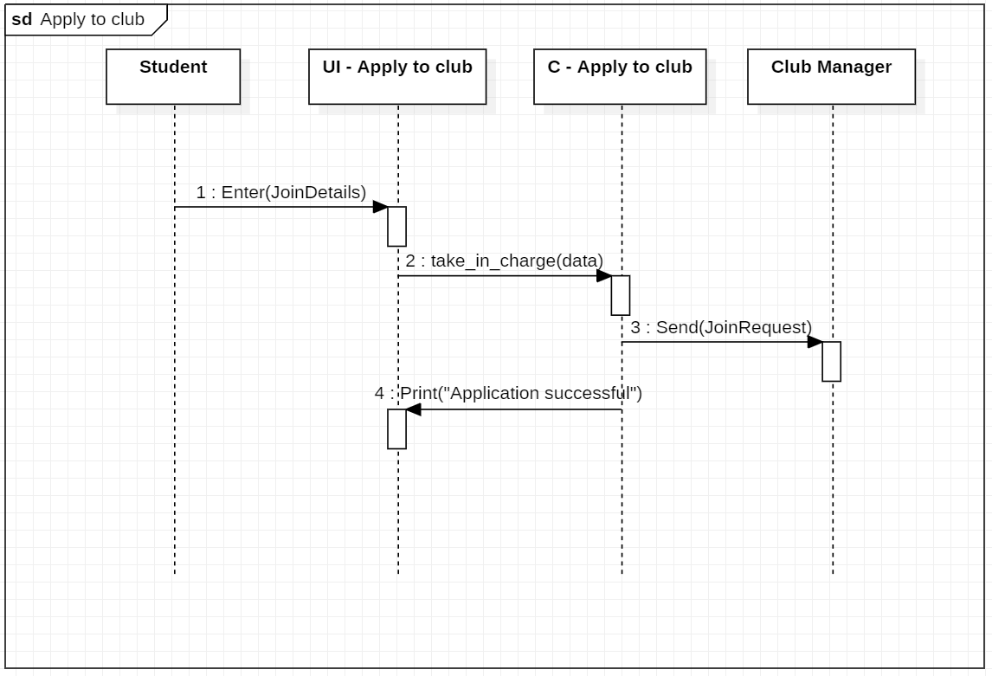

## •Class Diagram:

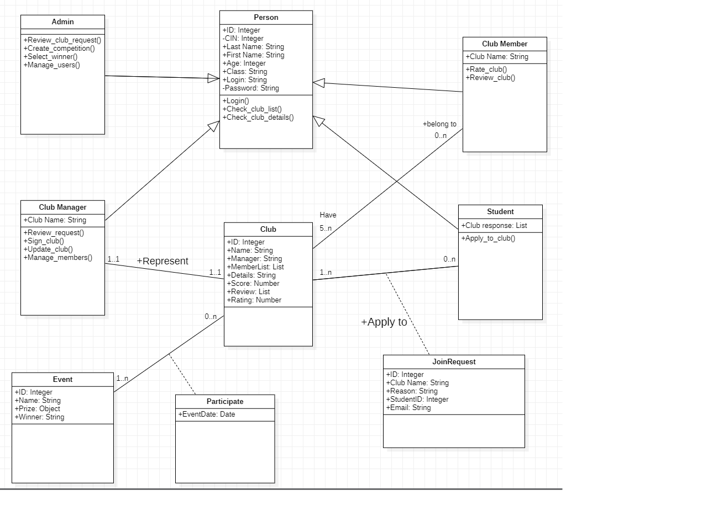

### Conclusion

The goal of this PWA is to connect students to the university life, providing them a platform to engage with various clubs and organizations on campus. The web app should allow students to browse, search, and join clubs based on their interests and availability. It should also provide club leaders with tools to manage their clubs, schedule events, and communicate with members.

In order to build this project, we will use technologies such as Angular, php and AdobeXD etc.